Share presentations

Save presentations as videos​
After you finish creating your presentation in PowerPoint, you can save it as a video to share with others.
- Select File > Export > Create a video.
- Select the quality of the video:
  - Presentation Quality - Largest file size and highest quality (1920 x 1080).
  - Internet Quality - Medium file size and moderate quality (1280 x 720).
  - Low Quality - Smallest file size and lowest quality (852 x 480).
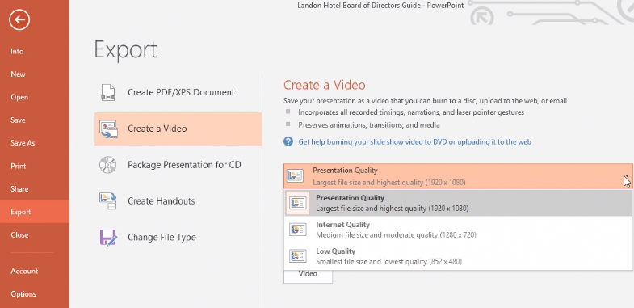
- Decide if you want to:
  - Use Recorded Timings and Narrations
  - Don't Use Recorded Timings and Narrations
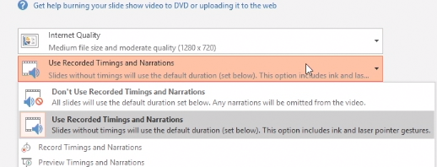
- In the Seconds spent on each slide box, select the default time you want to spend on each slide.
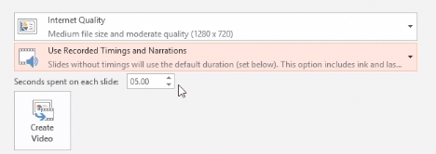
- Select Create Video.
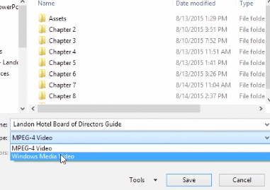
- Enter a file name and then browse to the location you want to save your video.
- In the Save As type box, select if you want to save the video as a MPEG-4 Video or Windows Media Video.
Tip: The MPEG-4 Video format is recommended for the best compatibility with video players.
- Select Save.

Remove sensitive information ​from your presentation
Before reusing or sharing a presentation, you can use Inspect Document to find and remove sensitive information or markups.
Use Inspect Document
- Select File > Info.
- Select Check for Issues > Inspect Document.
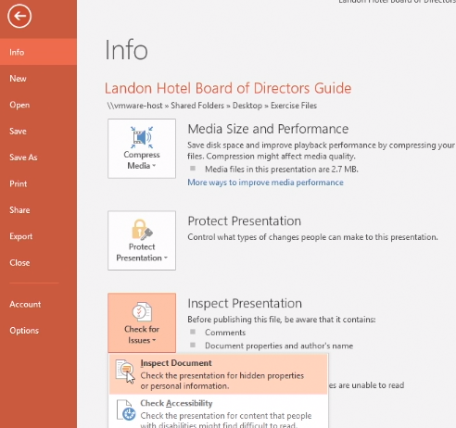
- Select the items you want inspected:
Note: If your organization customized the Document Inspector by adding Inspector modules, you might be able to check your documents for additional types of information.
  - Comments and Annotations: If you collaborated with other people to create your presentation, your presentation might contain items such as comments or ink annotations. This information can enable other people to see the names of people who worked on your presentation, comments from reviewers, and changes that were made to your presentation.
  - Document Properties and Personal Information: Document properties, also known as metadata, include details about your presentation such as author, subject, and title. Document properties also include information that is automatically maintained by Office programs, such as the name of the person who most recently saved a document and the date when a document was created. If you used specific features, your document might also contain additional kinds of personally identifiable information (PII).
  - Embedded Documents: If you added content from other files, such as pasting in a table from an Excel spreadsheet, the content from those files could be viewable.
  - Custom XML data: Presentations can contain custom XML data that is not visible in the document itself. The Document Inspector can find and remove this XML data.
  - Invisible on-slide content: Your presentation might contain objects that are not visible because they are formatted as invisible.
  - Off-slide content: PowerPoint presentations can contain objects that are not immediately visible because they were dragged off the slide into the off-slide area. This off-slide content can include text boxes, clip art, graphics, and tables.
  - Presentation notes: The Notes section of a PowerPoint presentation can contain text that you might not want to share publicly, especially if the notes were written solely for the use of the person who is delivering the presentation.
- Select Inspect.
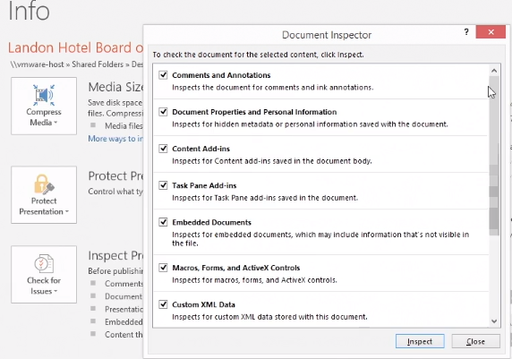
- After you see the results, you can choose to Remove items, such as Notes or Author or keep the information.
Or you can choose More Info to find out other information.
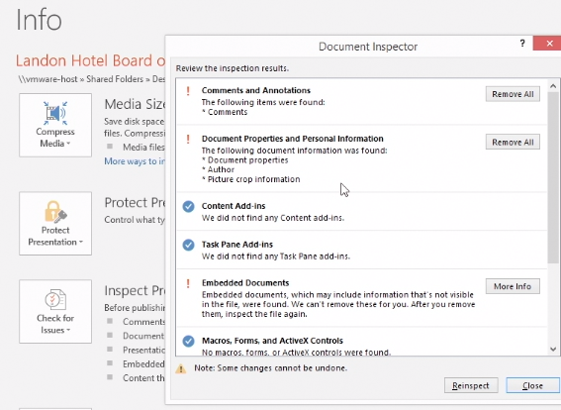
- When you are done, select Close.

Add and review comments​ in your presentation
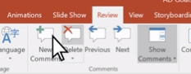
In PowerPoint, you can use comments to collaborate with colleagues to give notes and feedback.
Add a comment
- Select Review > New Comment.
Or select New if the Comments pane is open.
- In the Comments pane, type your message in the box and press Enter.
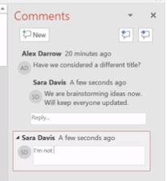
Note: A comment icon will appear on the slide. You can drag and drop it to put the icon next to whatever it is you are commenting on.
View and reply to comments
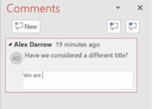
- Click on a comment icon on the slide.
The Comments pane will open and you can see comments for that slide.
- Select Reply to respond to a comment.
- Select the Next or Back buttons to go between comments and slides.
Delete a comment
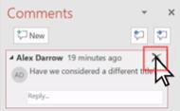
- In the Comments pane, select the comment that you want to delete, and then select the black X.
- On the slide, right-click the comments icon of the comment that you want to delete, and then select Delete Comment.

